ACH (Automated Clearing House)
# Source: AI Source: Provided by: [Data Path: Persons Table -> ID Column: 1, Name_En Column: Motasem Essam] -> From: [ChatGPT] on [1/21/2026]
An ACH (Automated Clearing House) is a batch-processing clearing system used to electronically process and settle low-value, high-volume transactions such as payroll, utility bills, direct deposits, and business payments between financial institutions.

🧠 Simple Definition
# Source: AI Source: Provided by: [Data Path: Persons Table -> ID Column: 1, Name_En Column: Motasem Essam] -> From: [ChatGPT] on [1/21/2026]
ACH is an electronic network that clears and settles batches of transactions between banks, usually within the same country, in a cost-effective and automated manner.

🏦 Core Functions of ACH
# Source: AI Source: Provided by: [Data Path: Persons Table -> ID Column: 1, Name_En Column: Motasem Essam] -> From: [ChatGPT] on [1/21/2026]
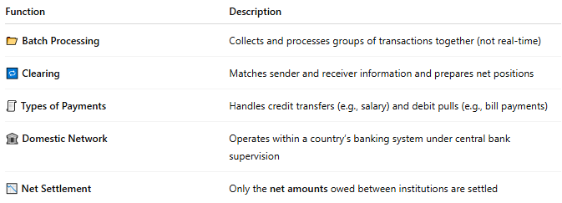

Function | Description
📂 Batch Processing | Collects and processes groups of transactions together (not real-time)
🔁 Clearing | Matches sender and receiver information and prepares net positions
🧾 Types of Payments | Handles credit transfers (e.g., salary) and debit pulls (e.g., bill payments)
🏛️ Domestic Network | Operates within a country’s banking system under central bank supervision
📉 Net Settlement | Only the net amounts owed between institutions are settled

📦 Examples of ACH Transactions
# Source: AI Source: Provided by: [Data Path: Persons Table -> ID Column: 1, Name_En Column: Motasem Essam] -> From: [ChatGPT] on [1/21/2026]
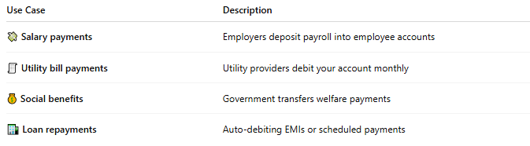

Use Case | Description
💸 Salary payments | Employers deposit payroll into employee accounts
🧾 Utility bill payments | Utility providers debit your account monthly
💰 Social benefits | Government transfers welfare payments
🏦 Loan repayments | Auto-debiting EMIs or scheduled payments

🌍 ACH Systems Around the World
# Source: AI Source: Provided by: [Data Path: Persons Table -> ID Column: 1, Name_En Column: Motasem Essam] -> From: [ChatGPT] on [1/21/2026]
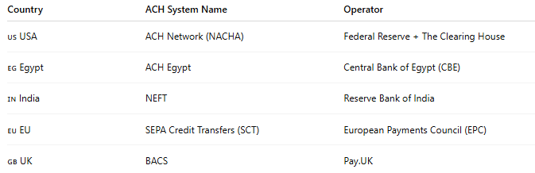

Country | ACH System Name | Operator
🇺🇸 USA | ACH Network (NACHA) | Federal Reserve + The Clearing House
🇪🇬 Egypt | ACH Egypt | Central Bank of Egypt (CBE)
🇮🇳 India | NEFT | Reserve Bank of India
🇪🇺 EU | SEPA Credit Transfers (SCT) | European Payments Council (EPC)
🇬🇧 UK | BACS | Pay.UK

⏱️ Settlement Time
# Source: AI Source: Provided by: [Data Path: Persons Table -> ID Column: 1, Name_En Column: Motasem Essam] -> From: [ChatGPT] on [1/21/2026]
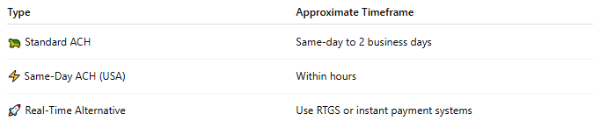

Type | Approximate Timeframe
🐢 Standard ACH | Same-day to 2 business days
⚡ Same-Day ACH (USA) | Within hours
🚀 Real-Time Alternative | Use RTGS or instant payment systems

✅ Benefits of ACH Clearing
# Source: AI Source: Provided by: [Data Path: Persons Table -> ID Column: 1, Name_En Column: Motasem Essam] -> From: [ChatGPT] on [1/21/2026]
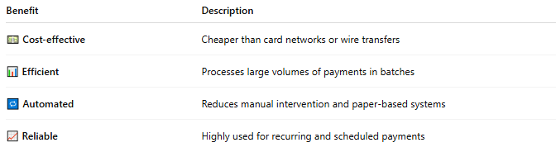

Benefit | Description
💵 Cost-effective | Cheaper than card networks or wire transfers
📊 Efficient | Processes large volumes of payments in batches
🔁 Automated | Reduces manual intervention and paper-based systems
📈 Reliable | Highly used for recurring and scheduled payments

⚠️ Limitations
# Source: AI Source: Provided by: [Data Path: Persons Table -> ID Column: 1, Name_En Column: Motasem Essam] -> From: [ChatGPT] on [1/21/2026]
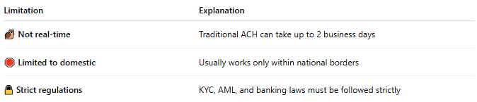

Limitation | Explanation
🐌 Not real-time | Traditional ACH can take up to 2 business days
🛑 Limited to domestic | Usually works only within national borders
🔒 Strict regulations | KYC, AML, and banking laws must be followed strictly

🧠 Summary
# Source: AI Source: Provided by: [Data Path: Persons Table -> ID Column: 1, Name_En Column: Motasem Essam] -> From: [ChatGPT] on [1/21/2026]
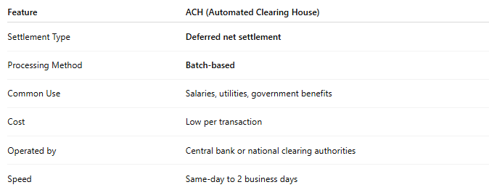

Feature | ACH (Automated Clearing House)
Settlement Type | Deferred net settlement
Processing Method | Batch-based
Common Use | Salaries, utilities, government benefits
Cost | Low per transaction
Operated by | Central bank or national clearing authorities
Speed | Same-day to 2 business days

